Welancora Gallery - Frieze LA 2026

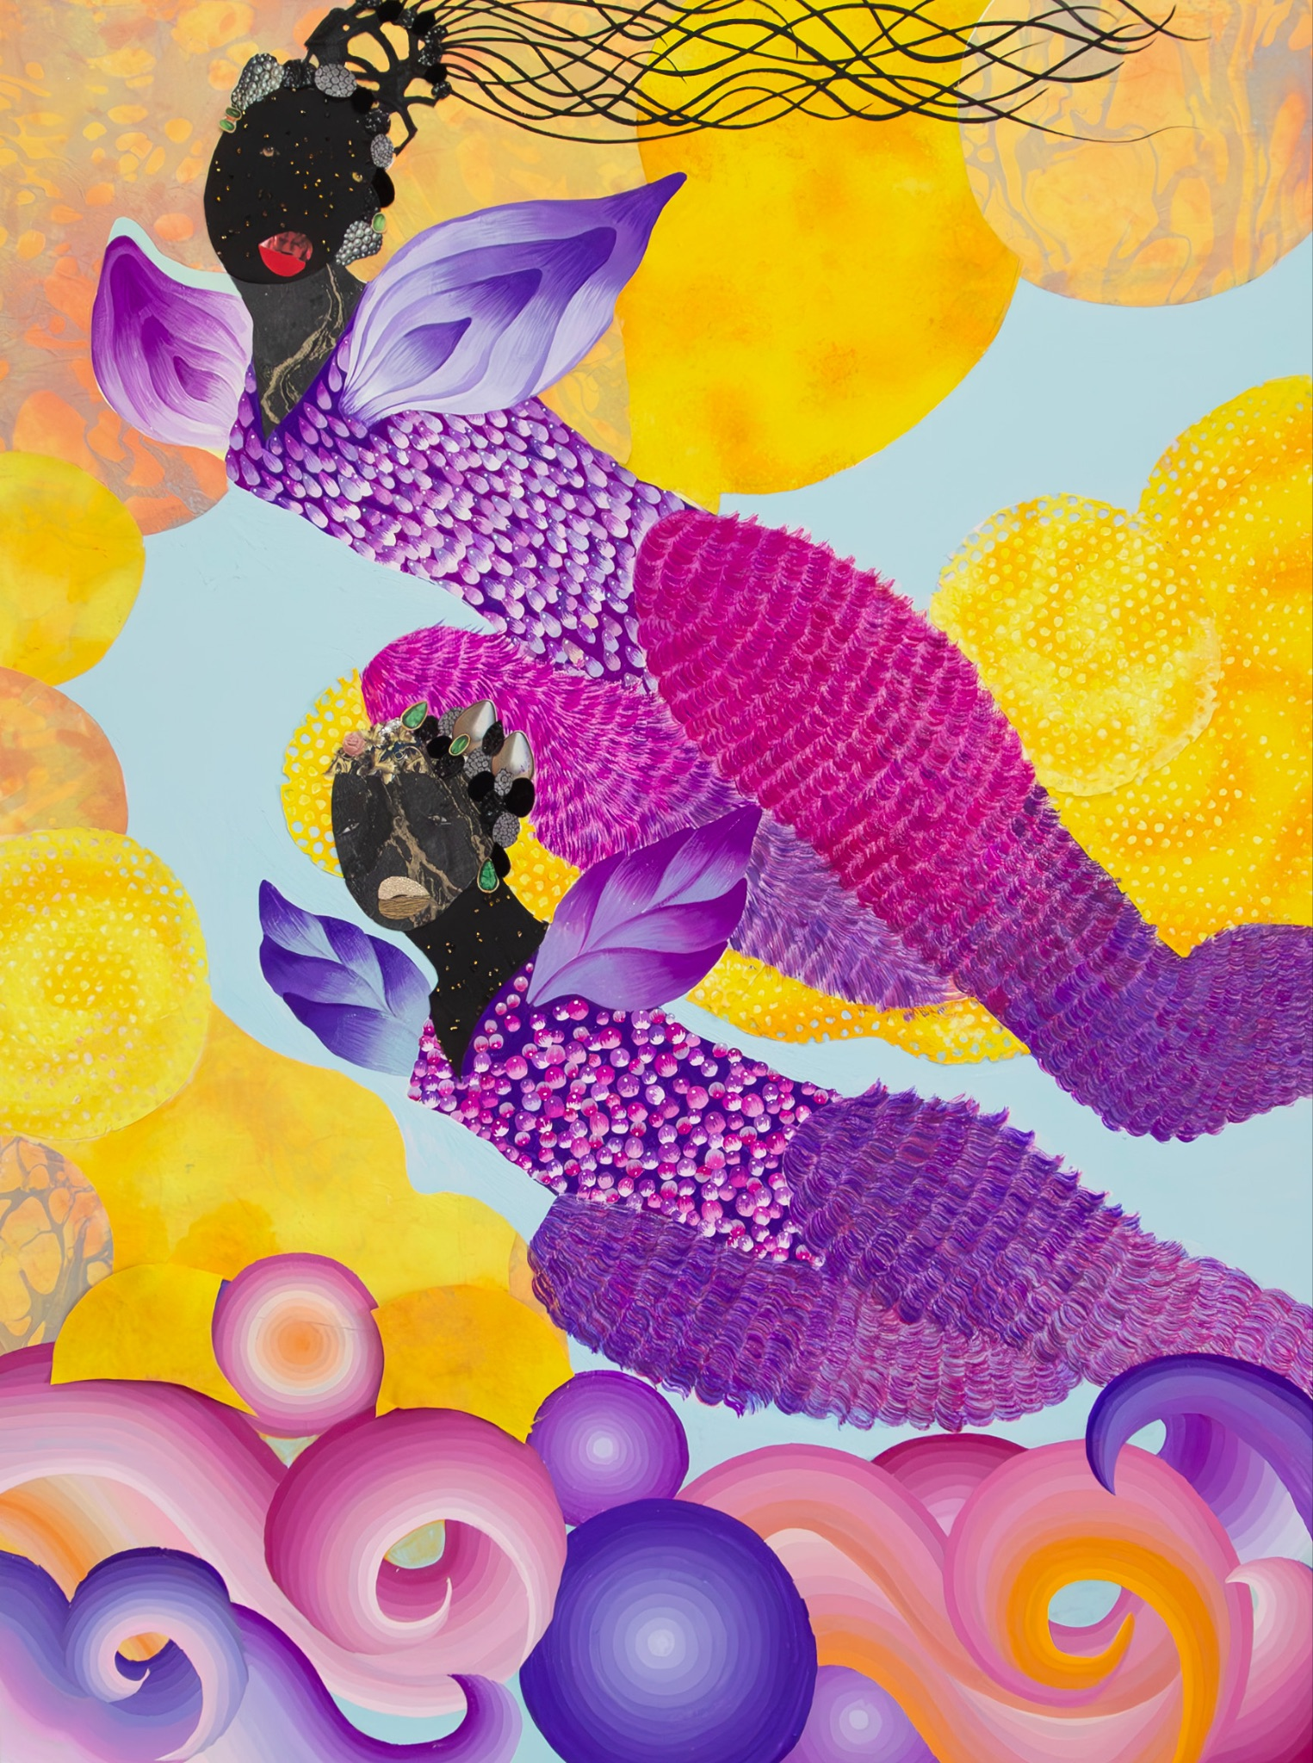
Grace Lynne Haynes, Swinging Between Two Worlds, 2025

We are delighted to announce our participation in Frieze LA 2026 in booth D12. The VIP preview will take place on February 26, 2026, at the Santa Monica Airport. The fair opens to the public on February 27th. This is the gallery’s fourth consecutive year in the galleries section of the fair.

Our presentation highlights the intergenerational nature of the gallery’s program, with works by Carl Hazlewood, Na’ye Perez, Debra Cartwright, Grace Lynne Haynes, Antonio Carreño, King David, and Ryan Cosbert. The presentation leans heavily toward the gallery’s focus on abstraction, anchored by Carl E. Hazlewood’s large-scale multimedia wall works. Across disciplines and generations, the artists in our presentation layer waterscapes, family stories, historical accounts, and personal reflections, creating a textured exploration of migration, selfhood, and resilience in diasporic Caribbean and African American experiences.

Carl E. Hazlewood (b. 1951. Guyana, South America) uses the structural language of abstraction as a clarifying act of progress in what he considers an unstable world. Through a suite of shapes and symbols, his work speaks to the power of resiliency through references to West African and Caribbean folklore. Parallel to his studio practice, Hazlewood co-founded Aljira, a Center for Contemporary Art in Newark, NJ, in 1983. Solo exhibitions of his work include BlackHead Anansi: Constellations at Charlotte and Philip Hanes Gallery, Wake Forest University, South Carolina (2023); Racing Thoughts-Fever Dreaming at Art Basel Miami Beach (2022); and BlackHead Lyricism at Welancora Gallery in Bedford-Stuyvesant, Brooklyn (2022). Hazlewood has been the recipient of fellowships at the MacDowell organization (2023, 2015); the Brown Foundation at the Dora Maar House, Ménerbes, France (2018); and the Bogliasco Foundation, Italy (2018). His fifty-two-foot-tall wall work, TRAVELER (2017), was commissioned by the Knockdown Center, Queens. Hazlewood participated in the Art Cake residency at Cordy and Ethan Ryman’s Studio Program in Sunset Park, Brooklyn (2020–22). Carl was elected a National Academician in the Class of 2025 by the National Academy of Design. His work is in the collections of the Ogden Museum of Southern Art, OMI International Art Center, The Francis J. Greenberger Collection, The Schomburg Center for Research in Black Culture, Skowhegan School of Painting and Sculpture, and The Dora Maar House, among others.

Grace Lynne Haynes (b.1992. California) investigates the relationship between painting, collage, and storytelling through the usage of materials such as gouache, glitter, hand-made paper, and sculpture to create a visual language of her own making. Her work uses Afrofuturistic aesthetics and science fiction references to create worldbuilding-driven narratives. Haynes incorporates references to Afrofuturism, ecological issues, Octavia Butler’s science fiction, and figuration to create surrealist alternative worlds that challenge Western theology and methods of image making. Through envisioning a future centered on Black women, her worldbuilding becomes a way to address the sexism and racism of both past and present while simultaneously scripting new realities. Her artwork has been featured on the cover of The New Yorker, and exhibited at Luce Gallery, Turin, Italy; Ontario Museum of History and Art, Ontario, California; and New Image Art Gallery, West Hollywood, California. She was featured in Forbes's “30 Under 30” list for Art & Style in 2020. Her work is in the collections of The California Museum of African American Art, The Perez Art Museum Miami, The X Museum in Beijing, and The Bunker Artspace.

Antonio Carreño (b. 1963. Santo Domingo, DR) is an abstract painter influenced by Norman Lewis, Joan Miró, and Wassily Kandinsky. Finding freedom in abstraction, his dynamic brushstrokes and layered forms are representative of his unique style, which he calls “magical realism.” A blend of indigenous traditions and modern art styles have imprinted their influence on Carreno’s work, rich in symbolism, memory, and personal history. It has an autobiographical quality, as he refers to his native Santo Domingo, one of the oldest cities in the world. Carreno has exhibited at Madelyn Jordon Fine Art (White Plains, NY), G.R. N’Namdi Contemporary (Miami, FL; Detroit, MI; Chicago, IL), Stella Jones Gallery (New Orleans, LA), Parish Gallery (Georgetown, D.C.), Dominican American Institute of Culture (Santo Domingo, DR), and Peg Alston Fine Art (New York, NY) among others. His work is in the collections of Arizona State University Art Museum, the Dominican American Institute of Culture, Museo de Arte Moderno Santo Domingo, and the Morris Museum.

Na’ye Perez (b. 1992. Los Angeles, CA) is a multidisciplinary artist based in Brooklyn, New York. Through his paintings, drawings, and socially engaged performances, Perez explores themes of shared experiences, identity, and accessibility. His incorporation of collage, strong bright colors, and a deep depth of field point to strong influences from pop culture and the surreal. With a focus on the Black and brown community, his work captures snapshots of tight-knit, nurturing relationships in everyday scenes. Perez has exhibited at NYC CULTURE Club, Tribeca, New York; Van Der Plas Gallery, East Village, New York; and Dinner Gallery, Chelsea, New York. He has received residencies from NEW WAVE, Pratt Institute, and The Shed. He is the recipient of the Pratt Circle Award and Outstanding Merit Award from Pratt Institute and the Black Artist Fund. Perez’s artworks are in the personal collections of Carrie Mae Weems, Derek Fordjour, and Yashua Klos. His work is also in the collection of the University of Toledo.

Ryan Cosbert (b. 1999. Brooklyn, NY) is a first-generation African-American artist whose work focuses on her own humanistic experiences, self-expression, political issues, and historical narratives. Cosbert aims to bring her viewers to see things from an internal/external perspective to ignite conversations while encouraging higher consciousness. Cosbert’s abstractions utilize found materials, blending the traditional grid format with abstraction to explore the consequences of subjugation and oppression along with their historical and generational impact on the Black community. Cosbert has exhibited nationally and internationally, with solo presentations at Welancora Gallery, Nicelle Beauchene Gallery (New York), Luce Gallery (Turin), UTA Artist Space (Atlanta), and Undercurrent (Brooklyn). Her work has also been featured in prominent art fairs, including 1-54 Contemporary African Art Fair, Dallas Art Fair, Felix Los Angeles, Untitled Miami Beach, and NADA Miami. Recent group exhibitions include Migrating Sun Part 1 at Welancora Gallery, Arrangements in Black at Phillips Auction, and The Shape of Things at Swivel Saugerties. She is recognized as a Barnes Foundation Scholarship Grantee (2021) and recipient of the Chairman’s Merit Award (2017–2021).

David Rampersad Jr, also known as King David (b. 1995. Brooklyn, NY), is a multimedia artist whose work reflects on heritage, ritual, and remembrance through the lens of abstraction. Through an evolving practice rooted in experimental methods, such as painting through window screens and the use of industrial tools in lieu of brushwork, David invites viewers into a layered visual language that bridges abstraction, personal history, and the ephemeral qualities of light. King David’s work has been exhibited nationally in solo presentations at Welancora Gallery, Sean Scully’s 447 SPACE, and Parasol Projects. His paintings have also been featured in group exhibitions at the Valentine Museum of Art, Welancora Gallery, 17 Frost Gallery, and Kinfolktech, as well as at art fairs including SPECTRUM Miami and The Other Art Fair in Brooklyn and Dallas. His work has been covered in The Brooklyn Rail and White Hot Magazine, along with institutional features by Gettysburg College, Dalton, and Prep for Prep.

Debra Cartwright (b.1988. Annapolis, MD) is an artist interested in depicting the relationship between the black female body and American medical history. She uses paint and mixed media to explore selfhood and her own positioning as the daughter of a gynecologist. Themes around her work include re-embodiment, myth creation, theft, and intimacy. She explores a critical understanding of the past while also proposing an examination of the present American healthcare system. A few of her solo exhibitions include presentations at Art Basel Miami Beach (2025, the main fair), Welancora Gallery (2025), Frieze LA (2024), Montclair Art Museum (2024), and BODE Projects (Berlin, 2023). She has participated in group exhibitions at TERN Gallery (Nassau, Bahamas, 2024); Swivel Gallery (New York, 2024); Fridman Gallery (New York, 2024), Untitled Art Fair Miami (2023); New York Academy of Art (2023); Sotheby’s (New York, 2023); Westbeth Gallery (New York, 2023); forMAH Gallery (New York, 2023); Allouche Gallery (New York; 2023), and CFHILL (Stockholm, Sweden, 2020). Cartwright was a resident at the Wassaic Project in 2024 and is currently in residence at Silver Art Projects. Among others, her works are in the collections of the Raclin Murphy Museum at Notre Dame University and Montclair Art Museum.

